IHSAAN JUNIOR SCHOOL



**MID - TERM I EXAMINATIONS, 2024**

**CLASS : P.4**

**SUBJECT : MATHEMATICS**

**DURATION : 2 HOURS 30 MINUTES**

**Name ____________________________________ Stream ________**

**SECTION A (40 MARKS)**

1. Add: 1 4

+ 2 3

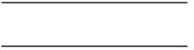

1. Write the place value of 7 in 16**7**2.
2. Draw the set symbol for an empty set.
3. Expand **379** using values
4. Write 20 in Roman numerals.
5. Shade P u Q

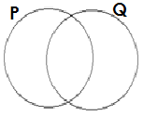

7. Find the next number in the sequence

20, 25, 30, 35, ______

8. Draw a kite in the space below.

9. Share 24 books amongst 6 boys.

10. Add: +

11. Change 4kg to grams.

12. Find the missing number.

 - 2 = 4

13. Write two hundred fifty six in figures.

14. Show **423** on the abacus.

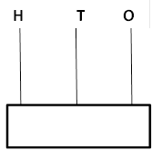

15. Find the distance around the figure below.

4cm

6cm

8cm

16. Simplify 4y + 3y

17. If stands for 5 apples. How many apples are represented by

18. Name the figure below.

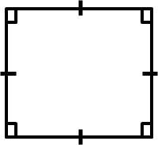

19. Shade a quarter of the diagramز

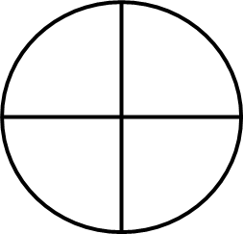

20. Add: Week Days

6 3

+ 2 2



**SECTION B**

21. Given that set A = (a, b, c, d, e, f) and B = (a, e, I, o, u).

a) Represent the above sets on the Venn diagram.

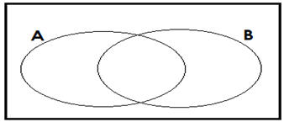

b) Find A $∩$ B

c) Find (A u B)

22. Work out the value of a, b, c and d in the magic square below. If it’s magic sum is 16.

|  |  |  |
| --- | --- | --- |
| 6 | c | 7 |
| d | 5 | b |
| 3 | a | 4 |

23. Find the missing numbers

a)  - 4 = 7

b)  + 5 = 9

24. a) Shade $\frac{1}{3}$ of the figure.

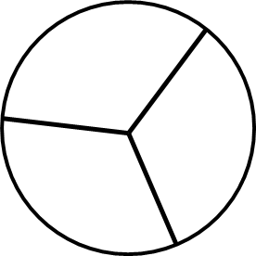

b) Write in words

c) Add: +

25. a) Add: 9 beads + 10 beads = __________

c) Multiply: 3 4

$×$ 2



b) Subtract: 4 3

- 3 3



26. a) Tell the time shown on the clock face below.

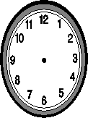

b) Change 5 weeks to days.

27. a) Name the shapes below.

|  |  |
| --- | --- |
|  |  |
|  |  |

b) Draw the shapes below.

|  |  |
| --- | --- |
| Kite | Cone |
|  |  |

28. A supermarket has prices displayed as follows.

A kg of rice sh. 3,600

A kg of sugar sh. 3,000

A packet of biscuits sh. 1,000

A bar of soap sh. 800

1. What is the most expensive item?
2. What was the cheapest item?
3. How much will Musa pay for a kg of sugar and a packet of biscuits?

29. Use the figure below to answer the given questions.

4cm

a

10cm

b

a) Find the value of;

|  |  |
| --- | --- |
| a = | b = |

b) Work out the area of the figure.

30. Ritah is 6 years old. Mary is 10 years old.

a) Who is younger?

b) Find their total age.

1. How old was Mary 2 years ago?

31. Given that a = 2, b = 4 and c = 5. Find the value of

i) a + b + c

ii) c – a

32. The graph below shows the number of pupils who played games in p.4.

30

40

0

20

10

|  |  |  |  |
| --- | --- | --- | --- |
|  |  |  |  |
|  |  |  |  |
|  |  |  |  |
| **Number of pupils** |  |  |  |
|  |  |  |  |
|  |  |  |  |
|  |  |  |  |
|  |  |  |  |

Football Volleyball Netball Tennis

**Types of games**

a) How many pupils played football?

b) How many games were played?

c) Find the total number of pupils who played all the four games.

**\*\*\*\*End\*\*\*\***